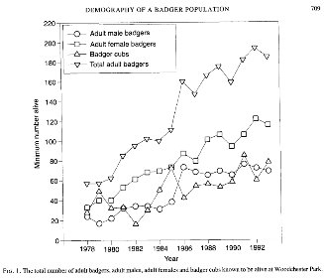
Rogers 1997 – woodchester
7.3 km^2 study area – used to calculate density from total abundance?
Fig 1 Total badger pop size by year

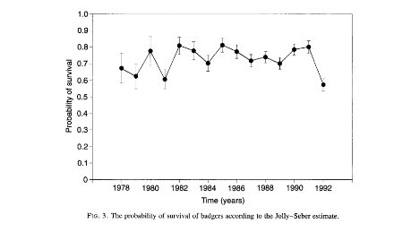
3 prob survival jolly seber by year- not needed

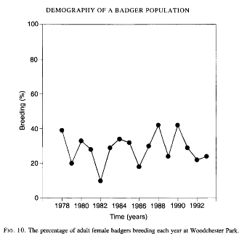
10 Percentage of adult fems that breed each year

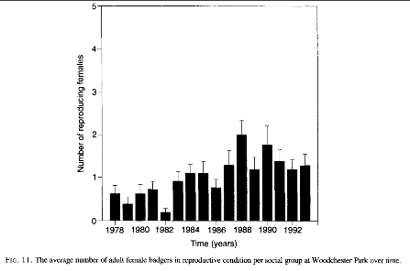
11 Av number adult fems in reproductive condition per social group each year

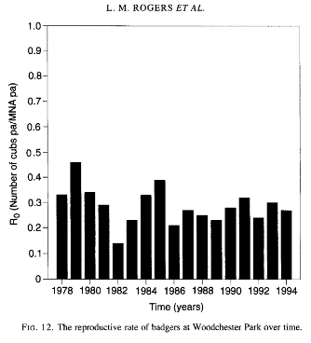
12 Reproductive rate = cubs per adult each year

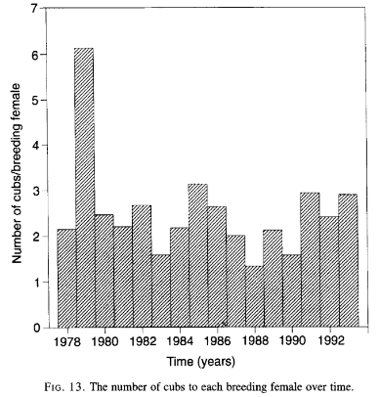
13- Cubs per each breeding fem by year- outlier of 6+ cubs per fem - low capture rate of adults - exclude this point

Combine in plot – year, variables, correlate overall pop size to vital rate changes (reproduction = cubs produced, females reproducing, av survival)

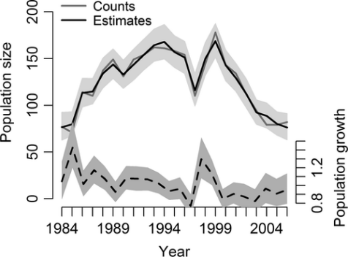
Mcdonald 2013 - woodchester
Fig 1 Pop size 1984 – 2006
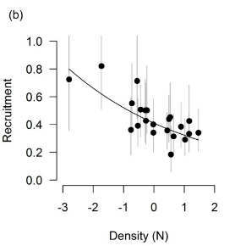
S2 Density and recruitment link – standardised density effect on recruitment rates in a badger population, showing the predicted relationship and the corresponding posterior means (points) and 95% CRI (vertical bars) from an IPM along with the predicted line from the posterior regression coefficients
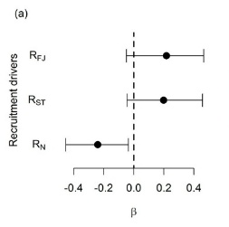
2e Regression slopes (β) describing the relationship between demographic rates; recruitment (R) and survival (S), and covariate effects; disease (D) and density (N). The posterior mean is displayed alongside the corresponding 95% credible intervals

Df can directly pull strength of density dependence on Survival and Recruitment (b estimation!)

Tuyttens – comparison sites
Fig 1 Cubs, adults and total densities (badgers/km^2) over years for different sites
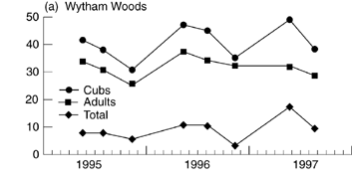
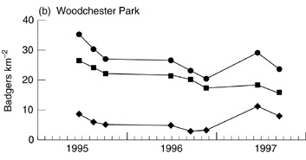
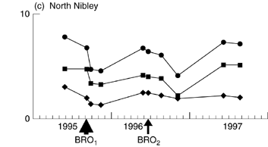
a= Wytham, b= woodchester , c= North Nibley

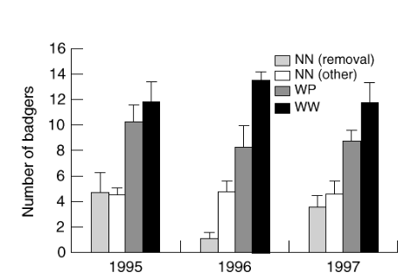
4 Badgers per social group over years at different sites

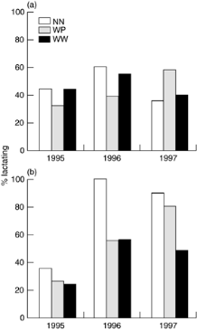
5 Percentage a) total fem and b) adult fem (>2yrs) lactating

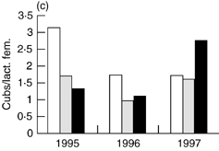
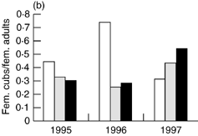
6 Cubs per fem adult and c cubs per lactating fem

Dataframe- density per year on social group size, females reproducing (per total or adult f), and per capita fem fecundity (per f or per lactating f)

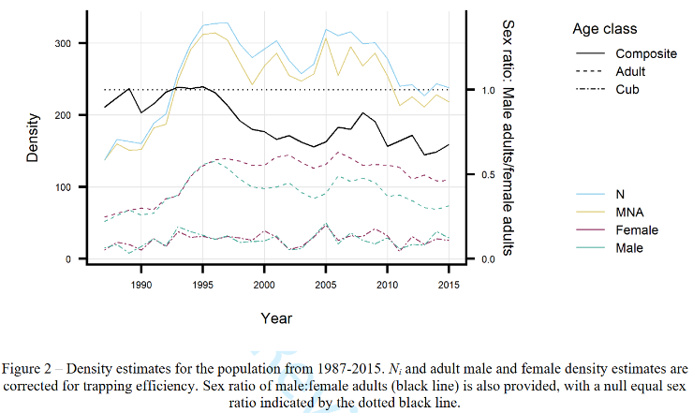
Bright Ross – Wytham woods
Fig 2 Density estimates by year

Fig 3 Temporal trends in a) survival and b) percentage of individuals reproducing by age class and sex (male &fem) Significant relationships by trend lines,
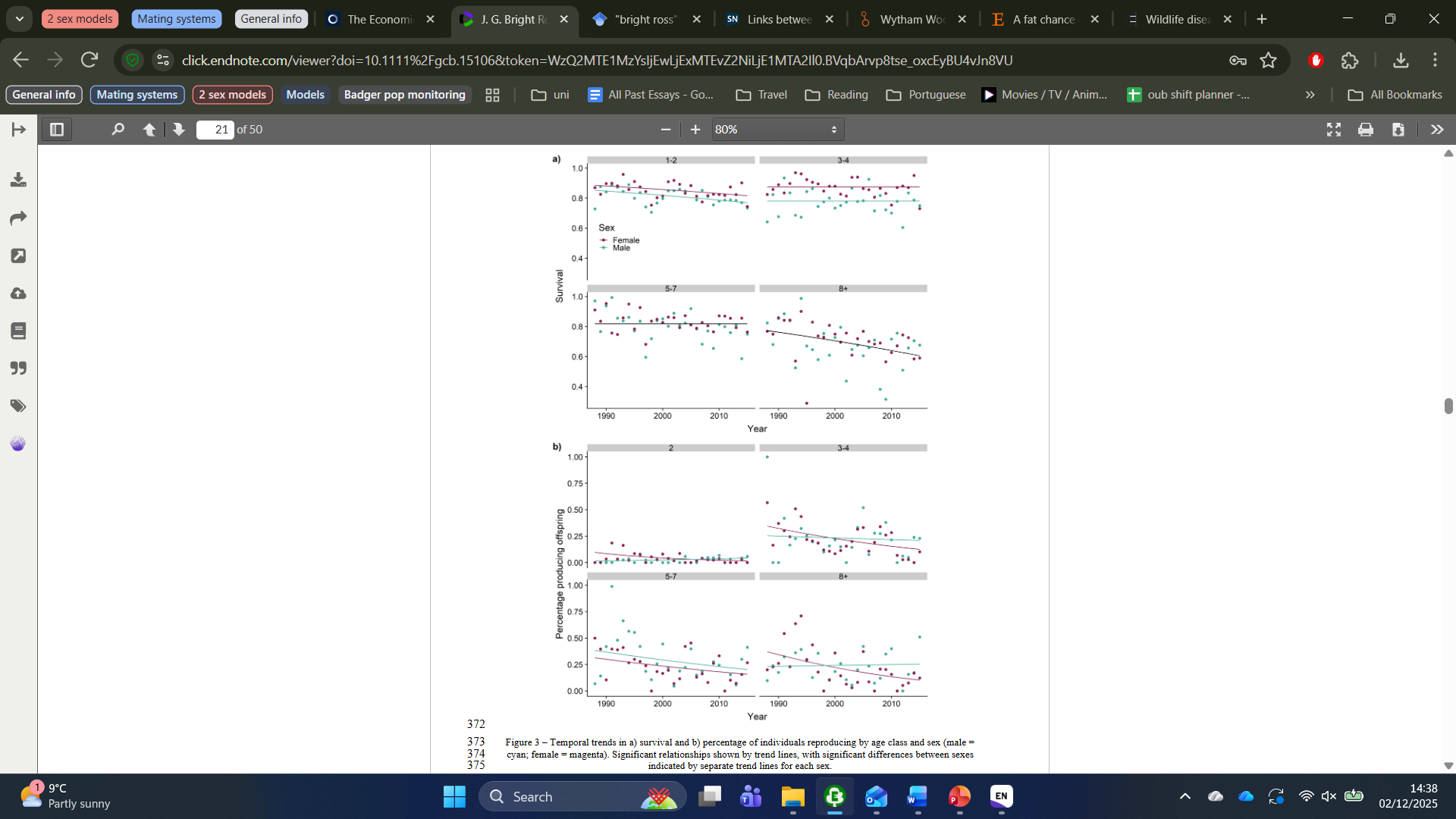

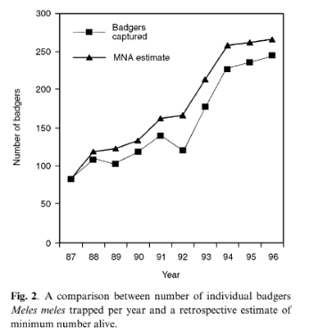
Macdonald 2002
Fig 2 = pop size over time as MNA estimates for all ages

Fig 7 = Mean group size as MNA over years
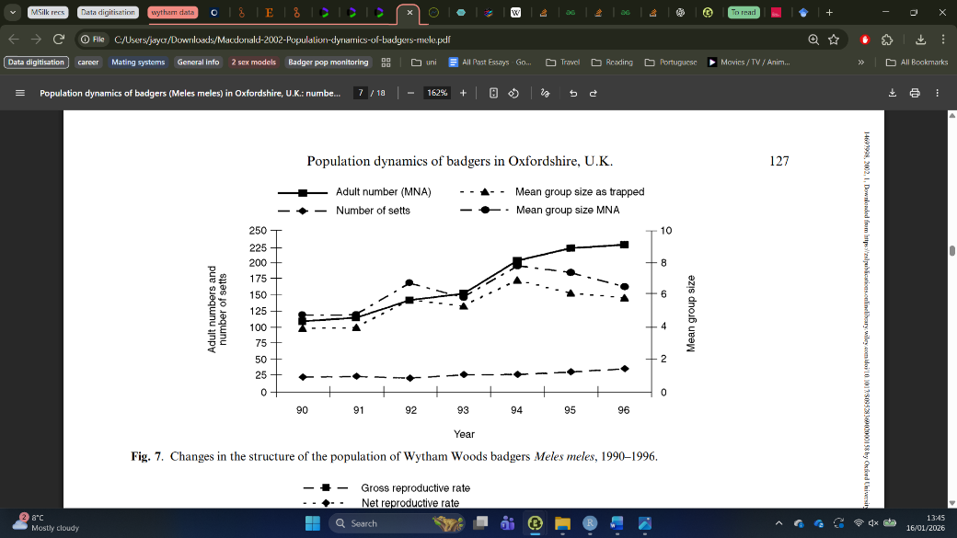
7b = setts per year

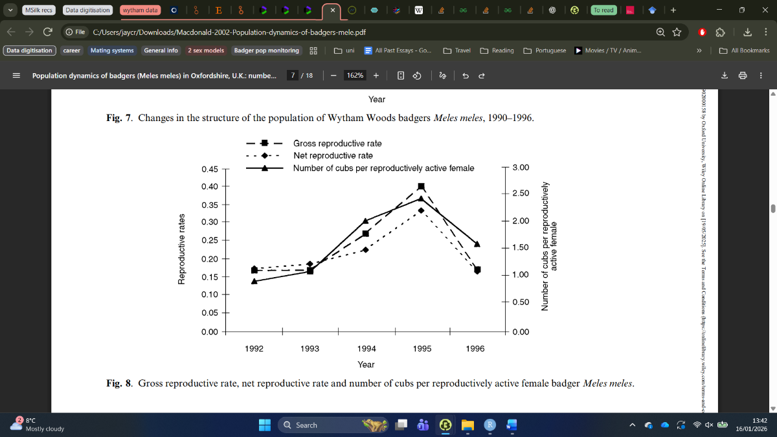
Fig 8 = reproductive rates per year
Gross rep rate = number of cubs in the annual cohort/MNA
Net rep rate = number of female cubs per female/MNA

8b = cubs per reproducing female per year
per capita cub productivity = number of cubs per annum/number of females observed to have produced cubs

Splitting into workable dataframes
All data from each paper into dataframe
- Macdonald 2002 – year, MNA and reproduction and group size

Focus for extraction
B from Mcdonald 2013, pop size per year and adjust scaling so we get same value for regression

Fertility mat – K, h,
cohort size = Tuyttens cubs per breeding fem, set density to 0 to estimate max cubs per adult.
Per cap fecundity = Tuyttens Cubs per adult fem in population
Fems breeding – varies with density (incorporated already as ricker?)

Surival values – Bright ross survival per age group – no data for cubs, must get elsewhere

META-POP
Group size over time (rogers table)
Movement paper – from big to small groups. Males more than females. 1-2 groups away. Males = prop adult fems. Most important is distance, others factors minimal
Distance function =

